Lab #1

Abbas Naqvi

# ***Task #1***

## Steps:

1. For creating new file, I used “nano file.txt” command.
2. Now file is created and then I write text on it. To save this text I used “ctrl + O” command and then press enter.
3. At the end I pressed “Ctrl + x” to close this file.
4. Then I create new text file with name file2.txt.
5. Now file2.txt is opened to copy the content of file.txt into file1 the command I used is “Ctrl + R”, then I entered the path at which file is stored and then press enter.
6. Now file.txt is successfully copied into file1.txt.

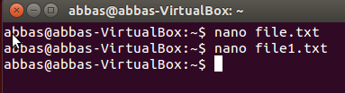

# ***Task #2***

## Steps:

1. For opening the Firefox from the terminal command which I used is “firefox &”.
2. For killing the Firefox, I used this command “pkill firefox”.

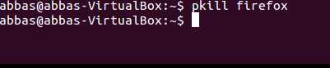

# ***Task #3***

## Steps:

1. To create directory, I used this command “mkdir dir1”.
2. Then I used this command “touch dir1/test.txt” to create file inside the directory.
3. Then I again create a new directory and then I used this command “cd dir1/” to go to the dir1 directory now to copy txt file from here I used this command “mv test.txt ../dir2/”.

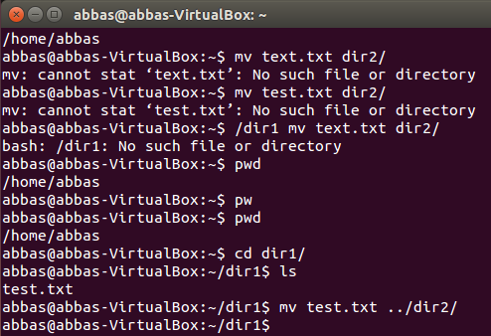

# ***Task #4***

## Steps:

1. For zipping two directories in one folder I used this command “zip zipped_directory.zip dir1 dir2”.

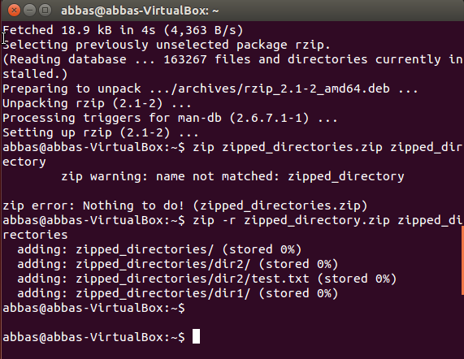

# ***Task #5***

## Steps:

* First I create lab folder inside it I create document folder using this command “mkdir -p lab/document”.
* Then to Unzip folder I used following command “unzip zipped_directory.zip –d lab/document”.

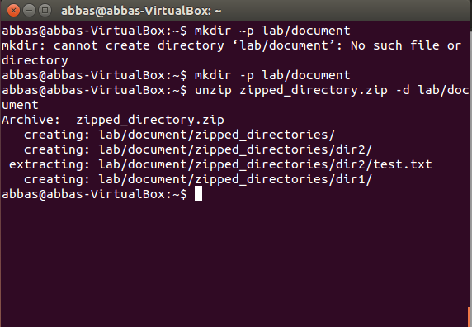

# ***Task #6***

## Steps:

